Select the second Dummy object and then select the MOTION TAB on the Command panel. See Figure 1.3. Expand the Assign Controller Roll-Out.

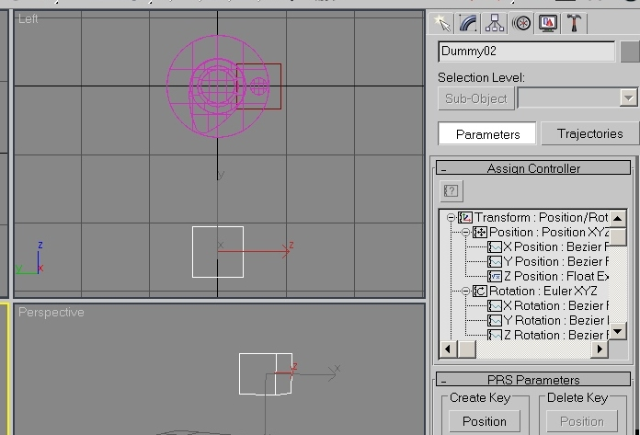
Assign Controller
Figure 1.3 Assign Controller menus for Dummy object 2.

Note that the Dummy2 object has 6 Degrees of Freedom, 3 Translations (Positions) and 3 rotations. We require to control the motion of the Dummy object in the ‘Z’ direction. Highlight the ‘Z Position’ Label and then select Assign Controller Icon. See Figure 1.4.

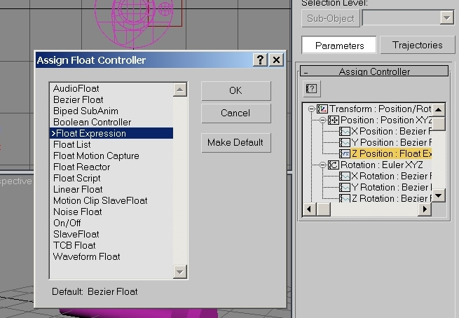 Figure 1.4 Assign Controller menus for Dummy object 2.
Select the Float Expression option and then select OK. The Expression Controller Dialogue appears. We need to Assign a name to the rotation angle of the shaft lets say cranking. Enter this in the Name box and select create.

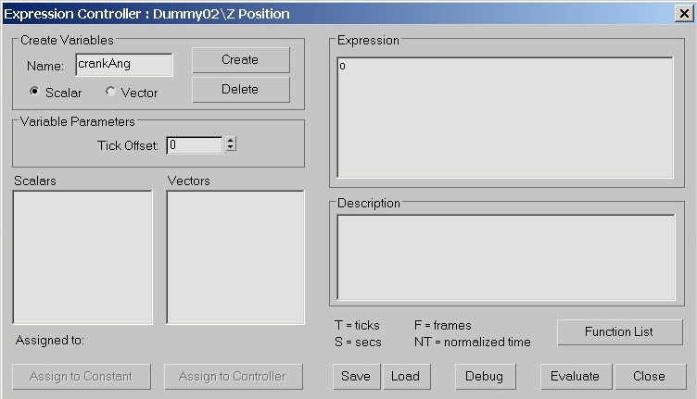Figure 1.5 Expression Controller Dialogue.

We now need to assign this name to a controller object, in our case the angular rotation of the shaft, about the ‘X’ axis. Select Assign to Controller button. The Track view selector appears. Expand the Objects track until you find the x-rotation for the shaft object. Select it and then hit OK. See Figure 1.6.

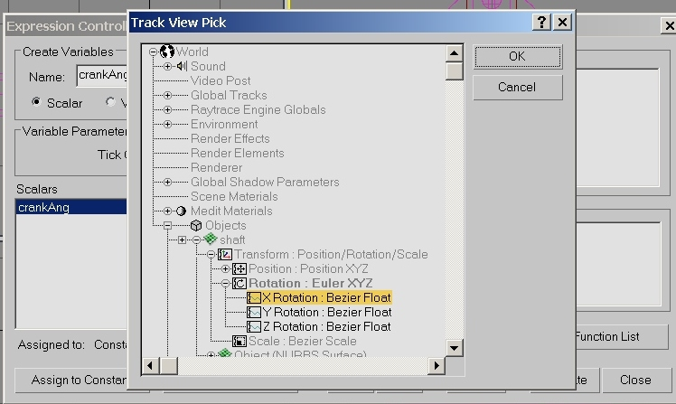
Figure 1.6 Select the shafts’ rotation about the x component for the variable crankAng.

We have now set up the variable crankAng to be equal to the value of the rotational angle of the shaft about the x-axis. See Figure1.7.
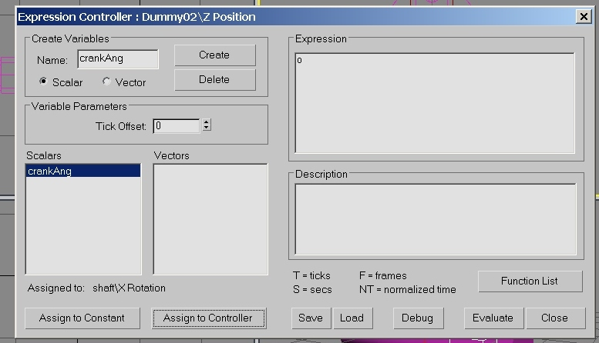
Figure 1.7 crankAng set up.

Now we need to enter the expression for the z position of the Dummy 2 object, which is a function of the variable crankAng. The expression we developed earlier needs to be entered into the expression box, currently showing 0. This requires us to code the expression which was,

$$\overline{\text{OP}}=6\text{.}\text{cos}θ−(\text{625}−\text{36}\text{.}(\text{sin}θ)^{2})^{1/2}$$

the syntax (or language style) would be as follows,

((6*cos(radToDeg(crankAng)))-((625-(36*((sin(radToDeg(crankAng)))**2)))**0.5))

note that θ is replaced with the variable name crankAng. The angles in 3DS are returned in radians, so they need to be converted to degrees, hence the use of the function radToDeg(). The problem with this type of coding is always the brackets. When you enter it take your time and always work from the inside out. See Figure 1.8

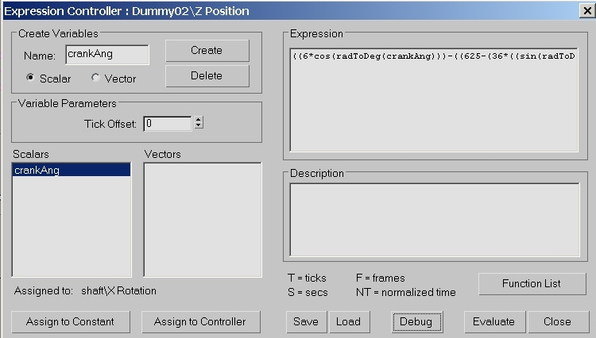
Figure 1.8 Expression entered.

When you have entered the expression hit the Debug button. It checks for errors in the expression and displays a value for the various parameters. Figure 1.9 correctly shows the value for the expression to be –19. try rotating the shaft and checking the values for the expression at different positions to check it is working correctly.

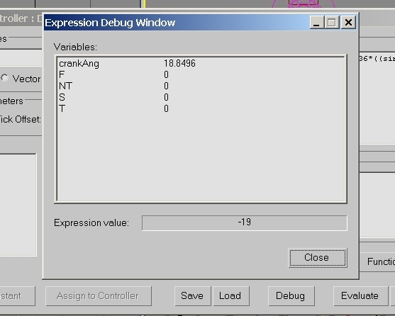Figure 1.9 Debug check and expression value

