TurnTool Tutorial 2: Gallery
Modeling and Text by Bo Drenov
Copyright © 2003 TurnTool ApS

A Brief introduction to TurnTool
TurnTool is a 3D technology, designed to transform your scenes, carefully modeled in your favorite 3D modeling application such as 3ds max, into fully interactive presentations in real-time 3D on the Internet.
TurnTool integrates with the modeling application, which makes working with it, as seamless as possible. When finished, your model is only a click away from your homepage.
In addition to creating smooth running visualizations from complex models, TurnTool offers the option to make them truly interactive in ways only your imagination limits.

Preparations
This is the second in a series of TurnTool tutorials. This time, our objective is to model the interior of a gallery with both direct and indirect sunlight to make it look as real as possible. You will make the camera interactive and allow a viewer walk inside the model using the keyboard and mouse. In addition, you will learn to control the scene's physics, i.e. the way the scene affects the user's movement.

The tutorial assumes at least basic familiarity with 3D Studio Max (max), and a copy of this is required to perform the steps herein.
You also need to install the TurnToolBox. Go to TurnTool’s web page: www.turntool.com and download the latest version.
Run it and follow the on-screen instructions for the installation.

If you wish you can add the TurnToolBox to the button set in the utilities panel: Open max, go to the "Utilities" panel and use the "Configure Button Sets" button to add the "TurnToolBox" button to the current button set. You can now use this button to open the TurnTool rollout panel.

Part One: Modeling
We will model the interior of a gallery and set up advanced lighting to make the scene look real life like.

Start 3ds max.

Go to Menu > Customize > Units Setup and click the button "System Unit Setup". Set "1 Unit =" to 1,0 Meters (figure 1).

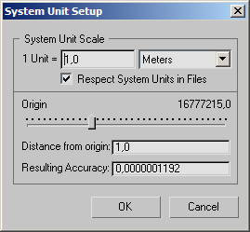
Figure 1: System Units Setup

Click "OK". Set the "Display Unit Scale" / "Metric" to "Meters". Click "OK" (figure 2).

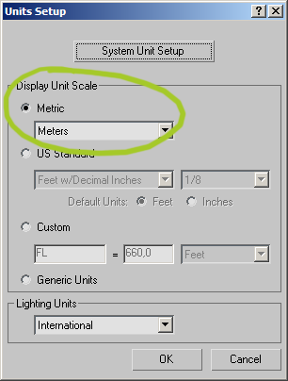
Figure 2: Units Setup

Go to the top viewport and make a box.

Move it to "Absolute World Center". Make sure the box is selected and right click "Select and Move" (keyboard shortcut: [F12]) (figure 3).
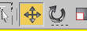
Figure 3: Move button

Enter 0,0 in all directions (figure 4).
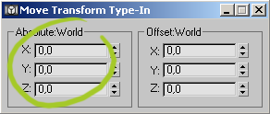
Figure 4: Move Dialog

Go to the modify panel (figure 5) and change the proportions of the box to 9m long, 14m wide and 5m high.

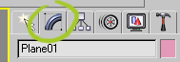
Figure 5: Modify Panel Button

Right click the box and select "Convert To" -> "Convert to Editable Poly".

Go to polygon mode by clicking the icon in the modify panel (figure 6).

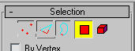
Figure 6: Polygon Mode

Select all the polygons of the box by pressing [CTRL] + [A].

Scroll down in the modify panel and find the button labeled "Flip" (figure 7). This will invert the polygons of the box, making it "inside out".

Figure 7: Flip Polygon Button

You will now make the opening in the ceiling, where the top window is:

Still in polygon mode, select only the top polygon.
Click the "Inset" settings in the modify panel (figure 8).
Figure 8: Inset Polygon Button

Inset the polygon by 2.5 m.
The result should look like figure 9.
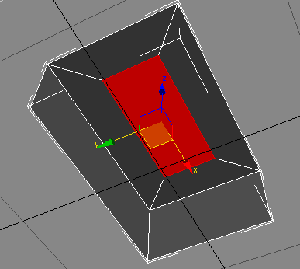
Figure 9: Result of the insets

TIP: Turn on Edged Faces in the perspective viewport by right clicking in the top left hand corner of the viewport and select "Edged Faces" from the popup menu. This enables you to get a better overview of the divisions of the mesh.
With the new polygon selected, click the "Extrude" settings and extrude it by –0.6 m (figure 10).

Figure 10: Extrude Button

Again, with the new polygon selected, inset it by 0.125 m. and extrude by –0.125 m.

Press [Delete] to erase the polygon that is to be the top window.

We have now made the top opening and the frame for the window and the result should look something like figure 11.

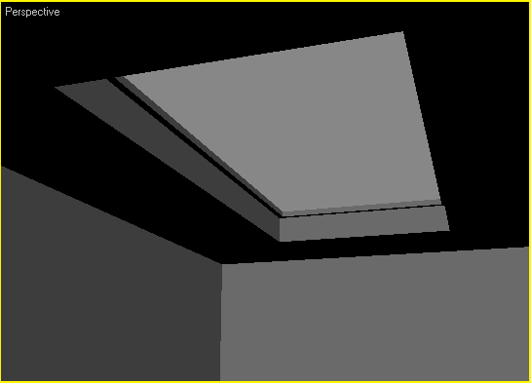
Figure 11: Result of the extrude

Using boxes, create a series of pillars on each side of the top opening, six on each side (figure 12).

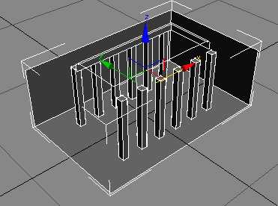
Figure 12: The pillars

Turn on vertex snap:

Right click the snap button (figure 13).

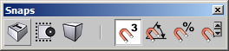
Figure 13: The 3D Snap Button

Check "Vertex" to turn on vertex snap (figure 14).

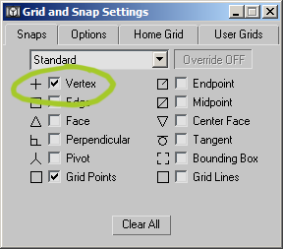
Figure 14: Select Snap Vertex

Make a box in the perspective view with a length of 0,5m, a width of 1,5m and a height of 3,5m.

This is to be the wall insets.

We will now evenly distribute the box along the walls.
With the box selected, find the "Spacing Tool" in the top toolbar of max behind the array button:
If the button isn’t activated in your user interface, find the tool in Menu > Tool > Array (figure 15).
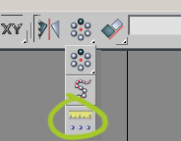
Figure 15: Spacing Tool Button

In the "Spacing Tool", click the "Pick Points" button (figure 16).

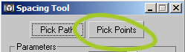
Figure 16: Spacing Tool Pick Points

Click and snap to the two lower corners of the wall as shown in figure 17.

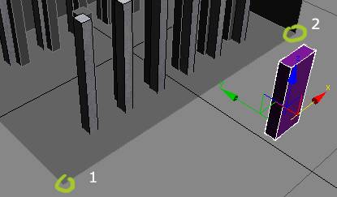
Figure 17: Use the spacing tool to evenly distribute 5 copies of the box
Set the spacing options as in figure 18.

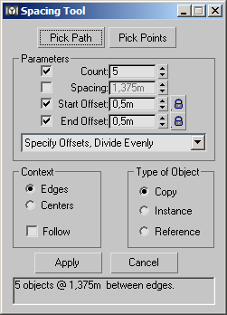
Figure 18: Spacing Tool Settings

Repeat the process on the opposite wall.

The result should look like figure 19.
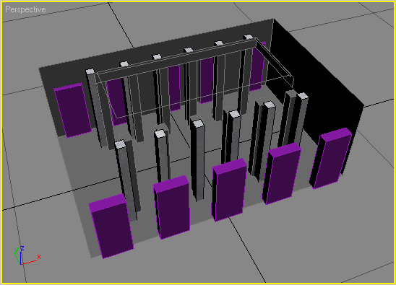
Figure 19: Spacing Tool result

Flip all of the boxes so their faces are turning inside out as the walls.

We will use the boolean operation to transform the walls and the wall insets into one object, read on:

TIP: Sometimes Max has some problems with Boolean operation. To make the operation more predictable, convert one of the Boxes to "Editable Poly" and attach the others, so we’ll end up with all the boxes as one "Editable Poly".

Go to the "Create" panel, and select "Compound Objects" from the dropdown (figure 20).

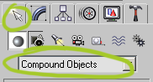
Figure 20: Create Compound Objects

Select the walls, and click the button "Boolean" (figure 21).

Figure 21: Boolean Button

Select the operation "Union" (figure 22).

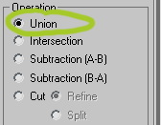
Figure 22: Boolean Union

Click Pick Operand B (figure 23), and click on the wall inset boxes.

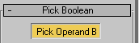
Figure 23: Boolean Pick Operand B

Convert the walls to an "Editable Poly", and go to polygon mode and delete the faces turning in towards the room.

Delete all the faces that make out the floor.

The model should now look like figure 24.

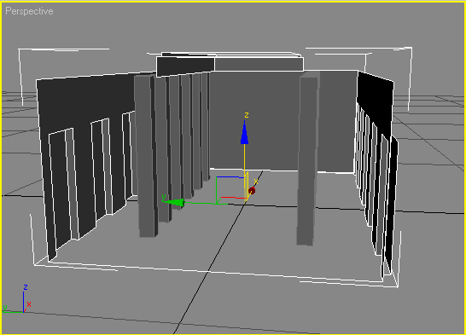
Figure 24: Boolean result
We must make a new floor that fits the recesses in the walls.
While the walls are selected, go to border mode in the modify panel (figure 25):
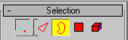
Figure 25: Border Mode

Select the lower open edge of the wall (figure 26).
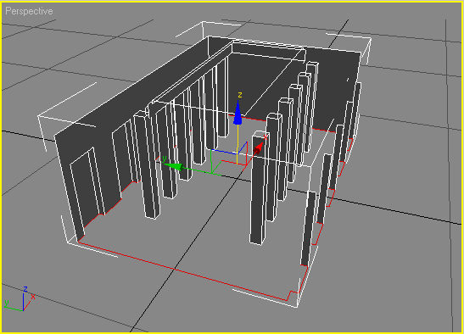
Figure 26: Selected Border
Click the button "Cap" in the modify panel (figure 27):

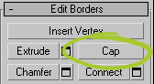
Figure 27: Cap Border

Make the top window framing with boxes (figure 28), using the spacing tool.

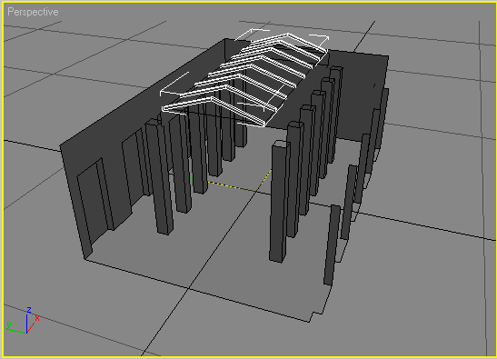
Figure 28: Top window frames

Combine all of the window frames to one editable poly.
Attach the top window, the pillars and the wall and floor object into one object:

With the wall and floor object selected, click "Attach" in the modify panel under "Edit Geometry" (figure 29).

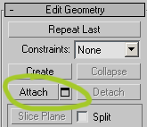
Figure 29: Attach Geometry

Create two new materials for the floor and the walls/window using the two supplied maps: "Concrete.png" and "texture_floor_wood.png" (figures 30 & 31).

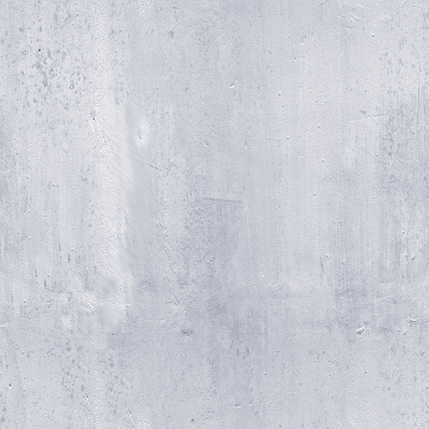
Figure 30: Concrete.png

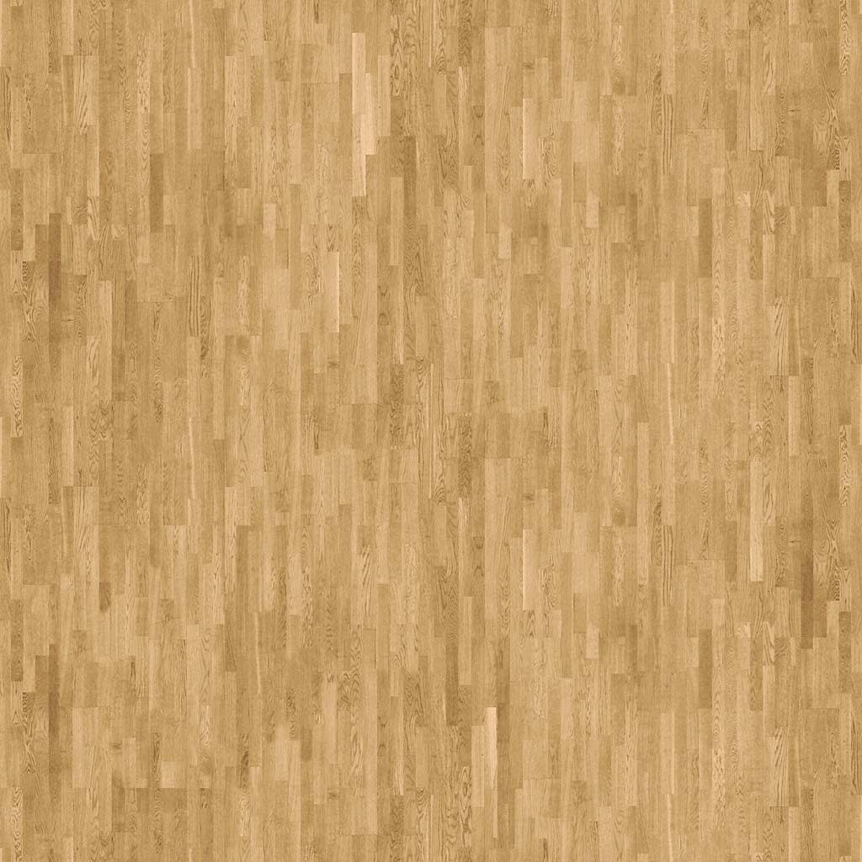
Figure 31: texture_floor_wood.png
Assign a new material to the model.
Set the map "Concrete.png" as diffuse map on the material.
Make an UVW map, and set the mapping parameters as in figure 32.
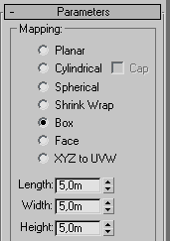
Figure 32: Mapping Parameters
In polygon mode, select all the faces of the floor.
Assign a new material to the selected faces.
Apply the map "texture_floor_wood.png" as diffuse map on the material.
Set "Map Channel" to 2 (figure 33).
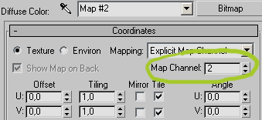
Figure 33: Material Map Channel
Create another UVW planar map on the model, and make it 5,0 long and 5,0 wide.

Set UVW "Map Channel" to 2 (figure 34).

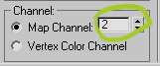
Figure 34: UVW Map Channel
We want to see the sky when we look out the top window instead of just a background color. Create a big sky sphere surrounding the model like in figure 35.
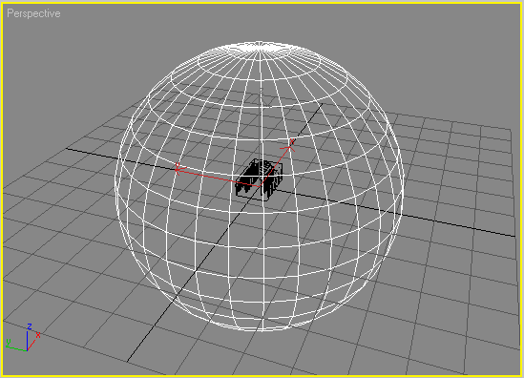
Figure 35: Sky Sphere with model inside
Convert it to an editable poly.

In polygon mode, select all the faces and flip them to make them visible from the inside (figure 36).
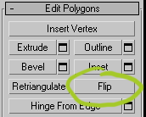
Figure 36: Flip Polygon
Assign a new material to the sphere and set the "Self-Illumination" to 100 (figure 37)
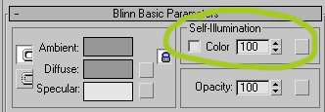
Figure 37: Material Self-Illumination
Create a UVW spherical map to the sphere.
Assign the map "sky.png" (figure 38) as diffuse map.

Figure 38: sky.png
Tile the map U: 2,0 and V: 1,0 (figure 39)

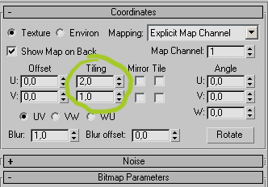
Figure 39: Material Mapping Coordinates
Rotate the sphere 90 degrees so the sky map will be visible from the top window (figure 40)
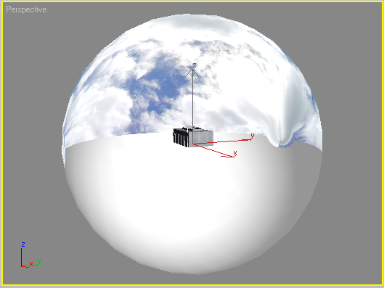
Figure 40: Sky Sphere with map
You can now cut away the lower geometry of the sphere to save render time, as it is not visible anyway. If you don't, it will be processed during rendering.

If you wish, you can put some paintings or pictures on the walls and/or a make statue or another object in the middle of the floor to make the scene more interesting.

Part Two: Lighting and Texture Baking

Now we will set up the lighting and "bake" the light calculations to maps. Normally the lighting model is simplified in real-time scenes to allow fast rendering speeds. Shadows and radiosity (materials and colors of objects affecting each other) is normally not possible. However, in scenes where objects and light sources do not move, the total lighting in the scene can be pre-calculated and stored in the textures of objects in the scene.
This technique allows us to create life like lighting in real-time 3D, such as TurnTool.

Set up a camera inside the gallery. Move it up to a height of 1,6 meters to create the illusion of a human eye view. Switch to camera view (keyboard shortcut: [c]).

First, we will set up the lights and do some test renderings until the lighting is satisfactory.

Make a "Target Spot" and make it shine through the window.

Adjust the lights hotspot and falloff so that it will only shine on the model itself. We are not interested in unnecessary calculations.

Turn on shadows and choose "Shadow Map" (figure 41) from the rollout, and set the shadow size to 2048 (figure 42).

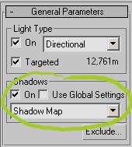
Figure 41: Enabling shadows for the light source
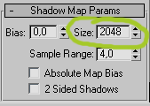
Figure 42: Setting size for the shadow map

Do a test render. It should look something like figure 43.

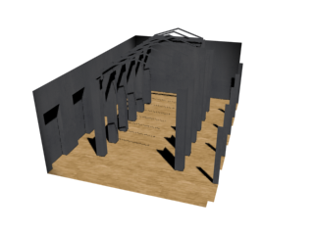
Figure 43: Rendered result with shadows

The shadows calculations will not detect the faces that are turning inwards. This is remedied by making the wall material 2-sided.

Go to the material editor, select the wall material and make it two sided (figure 44).
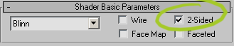
Figure 44: Making the material 2-sided

Do a test render from the camera view (figure 45).

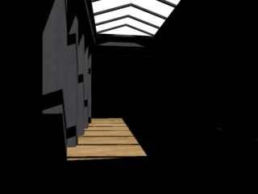
Figure 45: Rendered result with 2-sided materials

To get a more dramatic shadow, move the light a bit off center.

In a real life situation, this light would be enough to light up the room completely. This is caused by light diffusion, where lit surfaces will reflect light onto other surfaces which in turn will reflect light onto other surfaces and so on.

This can be simulated in max with the "Advanced Lighting" feature.

Go to Menu > Rendering > Advanced Lighting… (keyboard shortcut: [9]) and choose "Light Tracer" from the rollout (figure 46).

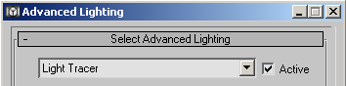
Figure 46: Activating the Light Tracer

When test rendering, turn down the "Rays/Sample" to e.g. 50. It is possible to evaluate the light situation, even if the quality of the rendering is low. "Rays/Sample" are the number of actual points that are sampled by Max. The lower number, the faster rendering.

The number of times the light is reflected from each face is set by Bounces. A minimum of 2 bounces is required to get an effect. Again, the higher the number, the more accurate the result but at the expense of render time.

The "Global Multiplier" will boost the lighting effect.
For testing purpose, we will go with the settings in figure 47.

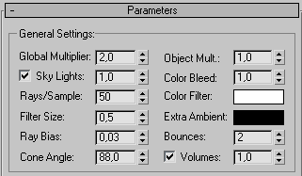
Figure 47: Light Tracer Parameters

This should produce a result like this where we can see the light from the floor is actually bounced to the wall (figure 48).

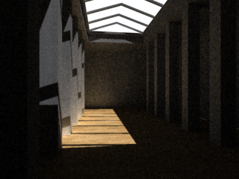
Figure 48: Rendered result with Light Tracer

Now we have simulated the direct sunlight. However, in a real life situation, the sky hemisphere will cast a diffuse light. This can be reproduced by the 3ds max "Skylight".

Go to the "Create" panel and create a skylight in the top viewport (figure 49).

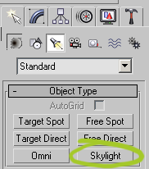
Figure 49: Skylight Button
Do a test render (figure 50). The skylight multiplier can be boosted to increase the effect of the light.
IMPORTANT: Hide the sky sphere before rendering with skylight. Unhide it again before exporting to TurnTool.
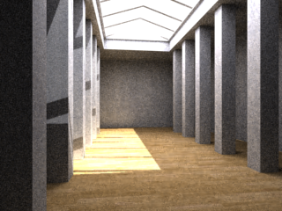
Figure 50: Rendered result with Skylight

Now increase the number of "Rays/Sample" until the rendering is satisfactory.

All the lighting will have to be "baked" into the materials of the objects before we can see the effects in TurnTool.

This is automated in 3ds max 5.x,
TIP: Remove all faces that aren’t seen from the inside of the room to reduce calculating time, and increase performance in TurnTool. E.g., the top and bottom faces of the pillars.

Select the model and go to Menu > Rendering > Render to Texture… (keyboard shortcut: [0]).
Click the button "Add"… and select "CompleteMap" (figure 51).

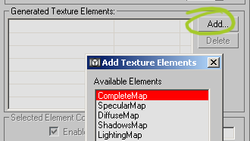
Figure 51: Add "CompleteMap"

Set the resolution to 2048 x 2048 for the final resolution.
TIP: When working with texture maps for real time display (e.g. TurnTool), it is important to make sure the width and height of the image used are numbers that are powers of two; i.e. 2^{n}, where n is any positive whole number or 0. This is simply a requirement of most video hardware around. If this requirement is not observed, the TurnTool viewer will resize the picture, if necessary, at runtime without any kind of filtering, the result of which is not always pretty. If math isn't your strong side, an easy way to remember these numbers is to start at 1 and keep doubling it until you reach a size close to the desired. Like this: 1,2,4,8,16,32,64,128,256,512 etc.
If you have an image where this isn't true, simply load it into Photoshop and stretch it to the nearest match of the above numbers, width and height need not be the same. Moreover, don't worry about stretching proportions. E.g., an image that is 200x400 should be resized to 256x512 or 128x256.

Click "Render".
The result should look like figure 52.
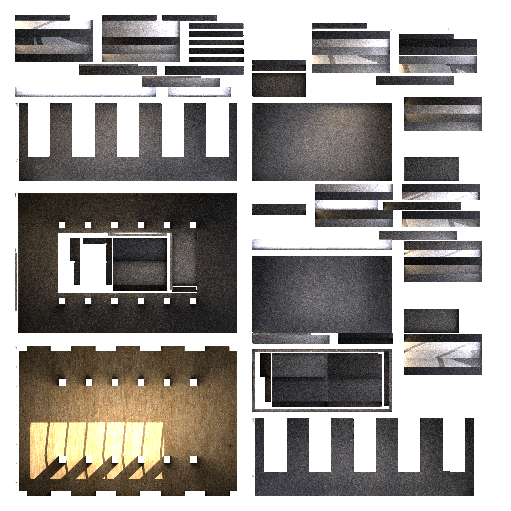
Figure 52: Rendered "CompleteMap"

TIP: It is a good idea to play around with the parameters for the texture baking parameters to get best result. For example, the wasted space between the texture elements can be reduced by reducing the spacing parameter. The padding parameter can add a border around texture elements to prevent "color bleeding" from the background color. It should be at least 1. Always try to reduce the amount of wasted space in textures, as it will not be used for the actual rendering, but will still consume video memory, which is a limited system resource.

The rendered material will now be shown in the view, but to enable it for rendering or TurnTool, do the following:
Select the model.

Open the material editor.

Select an empty material slot.

Click the button labeled "Standard" (figure 53).

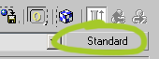
Figure 53: Change selected material

Select "Browse From": "Selected" (figure 54).

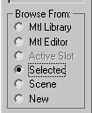
Figure 54: Select the rendered material into the selected material

Choose the material in the list and click "OK". This material is a shell material created in the "Render to Texture" process containing both the original and the new baked material.

Select "Instance" (figure 55).

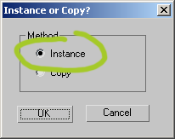
Figure 55: Select "Instance"

Discard the existing material in the material editor (figure 56).

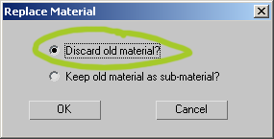
Figure 56: Select "Discard old material"

This is where we define whether the new baked material is seen in the viewport and / or the renderings. Choose the baked in both options (figure 57).

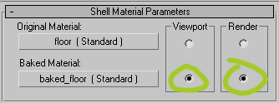
Figure 57: Shell Material Parameters

Turn off all the lights in the scene and the Light Tracer as well (Menu > Rendering > Advanced Lighting… (keyboard shortcut: [9])), as the light has now been precalculated.

Do a test render.

Part Two: TurnToolBox
In this part, we will prepare the model before exporting it to the Internet with the TurnToolBox.

We will set up camera and physics to create the illusion of walking around the scene in first person. The camera will be the eye of the viewer, and the TurnTool physics engine will make sure that the floor and walls cannot be passed through.

We’ll need a "Free Camera". We use the camera from earlier in this tutorial, and convert it from "Target Camera" to "Free Camera" in the modify panel (figure 58)

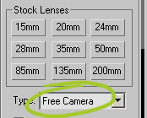
Figure 58: Change the Camera to "Free Camera"

Make a sphere in the top view. We don't want the sphere to be visible anyway, so set the sphere's number of segments to a minimum to save space. TurnTool will still interpret the object as a full sphere.

The sphere is the entity the viewer will control around the scene and is the basis of all the physics calculations (collision and gravity etc.). If the camera is the eye of the viewer, this sphere will be the body.
Note the importance of it being made in the top view. This way we know that it is facing front. It can be hard to tell which way a sphere is facing and we want the camera and the sphere to be facing the same direction, if they don't, controls will be strange.

Position the sphere right above the floor and under the camera. The alignment tool can be used to quickly align the camera to the position of the sphere. Select the camera; click the "Align" button in the toolbar (figure 59).

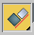
Figure 59: "Align" button

The object to which to align must now be selected. Click the sphere.
An "Align Selection" dialog will now appear. Center the camera relative to the sphere in both X and Z coordinates. We still want the camera to be at eye height so leave the Y position as it is (figure 60).

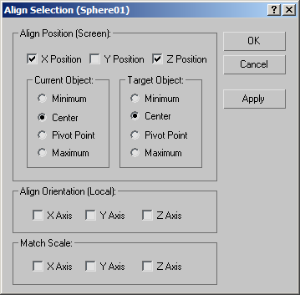
Figure 60: "Align Selection" dialog

If it isn't already, turn the camera to be facing front as well. The "Rotate Transform Type-In" can be used to do this. Select the camera, right click "Select and Rotate" and enter the values as in figure 61.

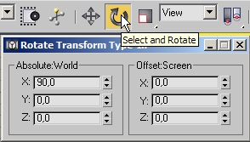
Figure 61: "Rotate Transform Type-In" dialog

The result should look like figure 62 in the left viewport.

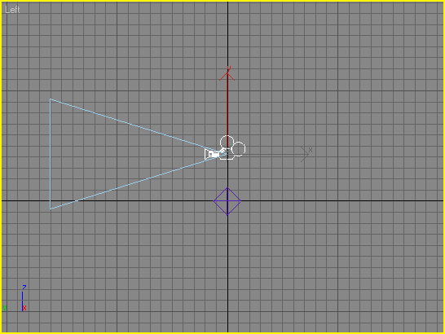
Figure 62: Camera and Sphere in the Left Viewport

To make the camera follow the moves of the sphere, the camera must be linked to the sphere, read on:

Click the "Select and Link" button on the toolbar (figure 63):

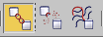
Figure 63: "Select and Link" button

Click and hold on the camera, drag the cursor to the sphere and release the mouse button.
Now the camera will stay in the same position relative to the sphere when the sphere is moved or rotated. If you want the camera to initially look in some other direction, you can now rotate the sphere horizontally, or the camera vertically.

It's time to tweak some TurnTool properties to make the sphere and the camera control the way we want.

Select the sphere.

Go to the TurnToolBox in the utilities panel and find the physics rollout. Check "Physics Object" to make the sphere a physics object. Adjust the other physics properties to the values shown in figure 64. These values determine how the physics object is affected by the scene. Generally, a little experimentation is encouraged to get the optimum settings for a particular scene.

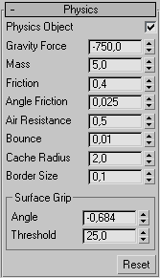
Figure 64: TurnTool Physics Setup

Adjust controller properties in the TurnTool controller rollout, to get a decent walking speed and to prevent the sphere from turning when moving the mouse up and down (figure 65).

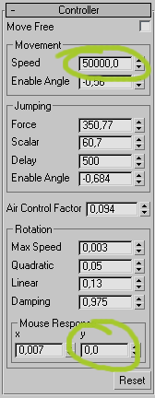
Figure 65: TurnTool Controller settings

Select the camera and find the TurnTool camera rollout. As the camera inherits the movement of the physics object it is linked to, we don't want the camera to move on it's own. We just want the camera to be able to look up and down when the mouse is moved up and down. Set the "Move Speed" and X "Rotation Speed" to zero (figure 66).

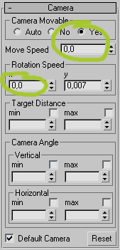
Figure 66: TurnTool Camera settings

Notice how we allow the camera to look only up and down, and the physics object to only be able to turn sideways. As the camera inherits the rotation of the physics object, turning the camera too, will cause it to not look in the direction of movement anymore. If we allowed the physics object to turn up/down, the camera wouldn't be above the physics object when looking up/down.
To stop us from falling through the floor or walking through the walls, we have to set up which objects are collidable.

To keep the physics calculations to a minimum, TurnTool only include objects with the special "Collidable Object" property, in its calculations. If the scene is very complex with many very detailed objects, it is often a good idea to make a simplified invisible clone of a model to work as collision geometry. What could be done is "outlining" our detailed geometry with simple boxes and planes with as few segments as possible.
Because we use precalculated lighting using textures, our model is already very minimal regarding the number of faces, so there is really no need to make special invisible collision geometry for the floor, walls and pillars. We have however, made a pretty detailed statue in the middle of the room. Make simple screen surrounding the sides of the statue.

Select the screen and the object comprising the floor, pillars and walls.

In the TurnTool miscellaneous rollout (figure 67), check "Collidable Object".
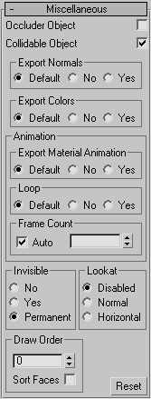
Figure 67: TurnTool Miscellaneous Settings for the Collision Screen

There are a couple of objects we don't want to be visible in the final result. Select the screen we just made and the physics sphere.

In the TurnTool miscellaneous rollout, check "Invisible" -> "Permanent"

Because we have a relatively small texture to describe all the detail in the scene, we should probably turn down texture compression a little. This will make the result look prettier at the expense of an increase in file size. In fact, it is often the major determining factor in the result file size. Generally, it depends on the textures and the required result file size how hard textures should be compressed. Some textures, such as photos, can be compressed a lot without a noticeable decrease in quality. Experimentation is encouraged to get the best results with a particular texture.

Find the TurnTool textures rollout and select "[Global Default]" from the list box. Move the wavelet slider down close to minimum (figure 68).

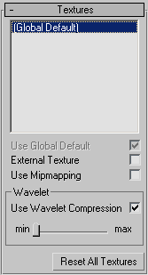
Figure 68: TurnTool "Textures" rollout

It's almost time to see what the result is. There are just a few adjustments left before the scene is finished.

To suit the generated HTML better to the scene, open the TurnTool HTML rollout and remove the check mark from "Transparent".

Because all the lighting in the scene is precalculated, the vertex normals are not needed. Set the ‘Global Light Mode’ as to ‘Baked Textures’ in the TurnTool scene export rollout (figure 69).

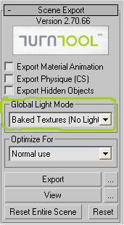

Figure 69: TurnTool "Scene Export" rollout

Export the TurnTool scene by pressing the "Export" button.
Open the scene in the Internet Explorer by pressing the View button. You should see something like figure 70.

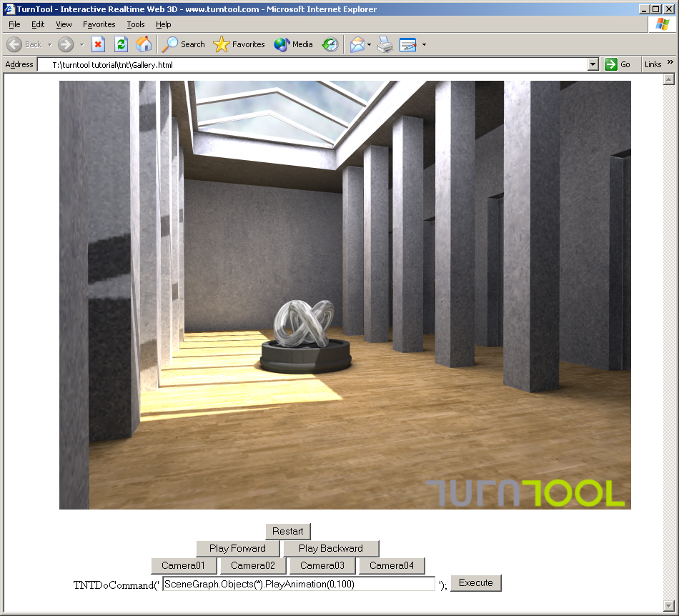
Figure 70: The TurnTool Scene

The scene is fully functional, and you can move around using the arrow keys and the mouse.

What's Next?
We have created a stunning interactive 3D model, from the relatively simple steps of this tutorial. It is all ready to upload to your own homepage. Just take the TNT file, the HTML file and the background picture and upload the files, just as you normally do when updating your homepage.
Imagine what can be accomplished with a little more practice and a little more time. Your imagination is the limit.
By the way: Don't discard your work so far; you will need it in a later tutorial in this series.
For additional inspiration, have a look at the online showcase on TurnTool's own web site www.turntool.com

